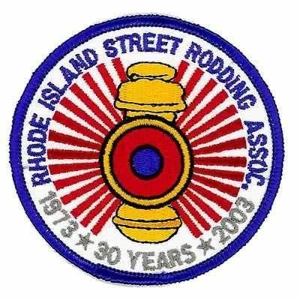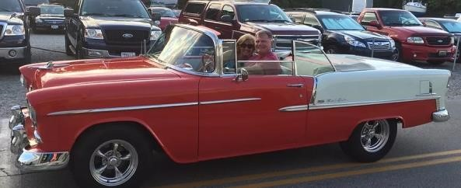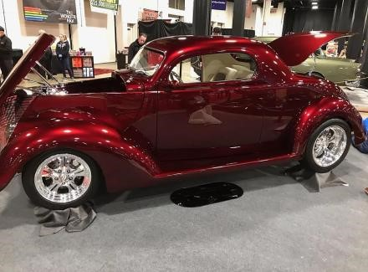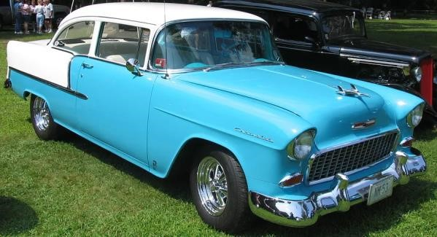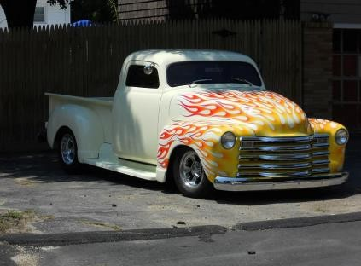

**RHODE ISLAND STREET RODDING ASSOCIATION**

**MEMORIAL DAY CAR SHOW**

**ANNUAL AUTOMOTIVE EXTRAVAGANZA**

**SUNDAY,**

**MAY**

**2023**

**28**

**,**

**JOHNSON WAR MEMORIAL PARK**

**1583**

**HARTFORD AVENUE, ROUTE**

**6**

**JOHNSTON, RI 02919**

**REGISTRATION FEE: $**

**15.00**

**REGISTRATION FROM 9:00 AM TO 12:00 NOON**

**AWARDS PRESENTED AT 2:00 PM**

**75**

**VEHICLE AWARDS**

**DASH PLATES FOR FIRST 200 VEHICLES**

**MUSIC BY “CRUISIN BRUCE PALMER”**

**BENEFITS JOHNSTON LITTLE LEAGUE**

**FOOD AND REFRESHMENTS AVAILABLE**

